ASSIGNMENT DAY – 5

Question 1. Add a 10 GB disk to the CentOS.

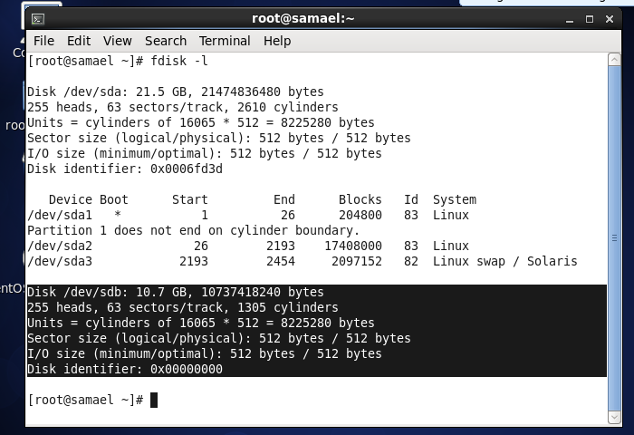

Question 2. Create 2 partitions, 4GB and 6GB of space respectively.

Question 3. Format 4GB with xfs and 6GB with ext4 file system.

Question 4. Mount 4GB and 6GB in /data and /music directory respectively.

Question 5. Create 1 file of 1GB in each of the mount point created above.

Question 6. Verify the disk consumption and disk space free in the mounted partitions.

